Boulevard beer page on website
From Boulevard Brewery:
Boulevard Unfiltered Wheat Beer–
is a lively, refreshing ale with a natural citrusy flavor and distinctive cloudy appearance. This easy drinking American-style wheat beer has become our most popular offering, and the best-selling craft beer in theMidwest.
Boulevard Pale Ale– is a smooth, fruity, well-balanced beer with year-round appeal. A variety of caramel malts impart a rich flavor and amber color, while liberal use of whole hops adds zest and aroma. Pale Ale is the first beer we brewed, and continues to be a perennial favorite.
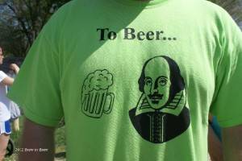Boulevard Amber Ale– is an exceptionally well-balanced beer, complex yet thirst-quenching. American pale malt provides a firm foundation.
English specialty malts impart a nutty sweetness, perfectly complemented by noble German hops. The deep coppery color holds the light, reflecting a ruddy glow, and the finish is clean, round, and delicious.
Lunar Ale– Our first new year-round beer since 1996, Lunar Ale is in a category all its own. Brewed using a unique aromatic yeast, this refreshing variety is best described as a cloudy brown ale with a complex, malty aroma and flavor, and a crisp, dry finish.
Boulevard Single-Wide I.P.A.- is our take on a style that originated in 18th century Great Britain. This American version—inspired by our Smokestack Series Double-Wide I.P.A.—boasts a heady combination of six varieties of hops, some of which were employed for dry-hopping.
Bully! Porter-The intense flavors of dark-roasted malt in Boulevard’s rendition of the classic English porter are perfectly balanced by a generous and complex hop character. Bully! Porter’s robust nature makes it the ideal companion to a variety of foods, from seafood to chocolate.
Dry Stout– Velvety black and perfectly opaque, our bottled Dry Stout is the somewhat livelier companion to our popular draught version of this enduring style. This surprisingly smooth, drinkable beer is a delightful harmony of smoky roasted flavors and tangy, coffee-like notes.
Pilsner– Like many American burgs, our town was once home to a number of small, regional breweries. As they 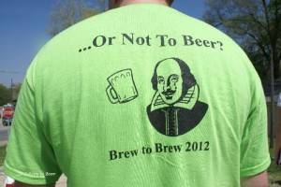disappeared, so too went the full-flavored but easy drinking classic American lager. Today, we salute these bygone breweries and revive their legacy with Boulevard Pilsner: 100% malt, real hop character, unpasteurized. It’s the taste of tradition.
From FreeState Brewery:
Ad Astra Ale– This ale is the first brewed in Kansas since pioneering days. The name “Ad Astra comes from the Kansas State Motto – Ad Astra per Aspera, Latin words meaning “To the Stars through Difficulties”. We’ve blended Pale, Caramel, and Munich malts for a rich amber beer. The hops balance this malty sweetness, and we’ve chosen Northern brewer and Fuggles hops for their flavor.
Belgian Wheat– This traditional Witbier, or White Beer, employs unmalted wheat and oats to contribute a haze that gives the beer it’s whitish appearance. Witbiers are spiced with orange peel and coriander seed…flavors that are further enhanced by the tart, spicy Belgian yeast strain and lemony Simcoe hops. It all adds upto an extremely refreshing summer beer.
Copperhead Pale Ale– Silver Medal Winner 1997 World Beer Championships – India Pale Ales. This flavorful beer is made in the style of the India Pale Ale Style originally manufactured in Great Britain for their colonies in India, but with an American twist. The
harsh travel that the beer had to survive required a strong, hoppy beer. The Hops and the high level of alcohol helped buffer the beer through its long travels. Made with flavorful and full bodied Pale Ale malt combined with a touch of caravienne for color and carapils for body, the rich flavor of this beer is matched and enhanced by a very generous portion of Centennial and Cascade hops. The Cascades give this beer its distinctive floral aroma and a uniquely American character.
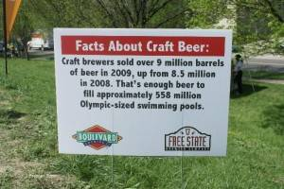Hop Jack Ale– First the name – Hop Jacks (or Hop Backs as they are also called) are pieces of traditional brewing equipment that are used to add fresh hop flavors and aromas to the hot wort as it is transferred from the brew kettle to the heat exchanger. Fresh hop flowers are placed in the Hop Jack for the very freshest hop character. This beer is one of a series that will showcase the diversity of hop varieties available to
us. Each batch of Hop Jack Ale will have the same malt recipe but will differ in the hops used. The ibu’s will remain the same also, allowing the drinker to appreciate the differences between hop varieties. The malt profile for this beer is very simple, using only pale ale malt and a very light caramel malt. Served unfiltered. Stop in and see what hop we used this time.
Mass Street Marzen– This malty sunset-hued lager gets its name

Donations page
We want to thank all past, current, and future Brew to Brew relay and solo runners. Your participation enabled us to donate $40,000 to the Cystic Fibrosis Foundation (CFF) in 2015. Teams can set up a fundraising account here and keep track of donations as they are made. Get busy and see how close you are to becoming the recipient of the "Most Generous" award.

